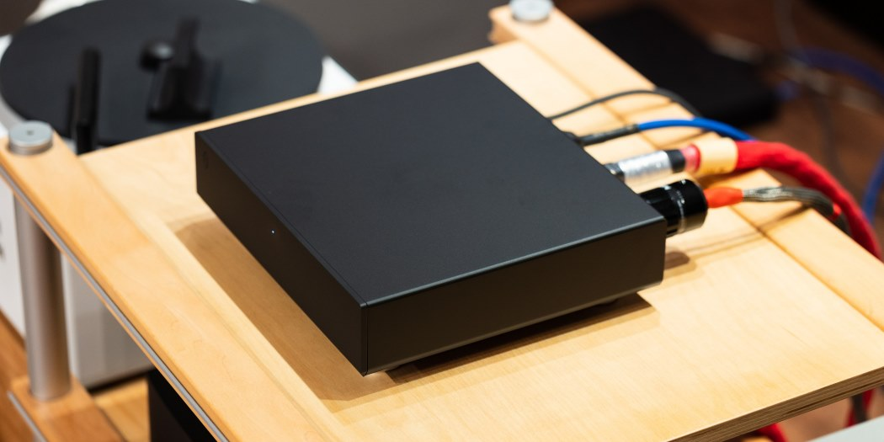
After an extensive year-long research effort, COS Engineering, a prominent Taiwanese brand, has finally introduced the S10 Switch network switch this year. The COS team possesses a profound expertise in electronics and an in-depth understanding of high-end audio systems, catering to passionate audiophiles. They specialize in DAC and network digital streaming design and have successfully obtained Roon Ready certification. Their flagship product, the D10 DAC, not only offers exceptional audio quality but also provides users with the convenience of multiple playback options by incorporating both network streaming and preamp interfaces.
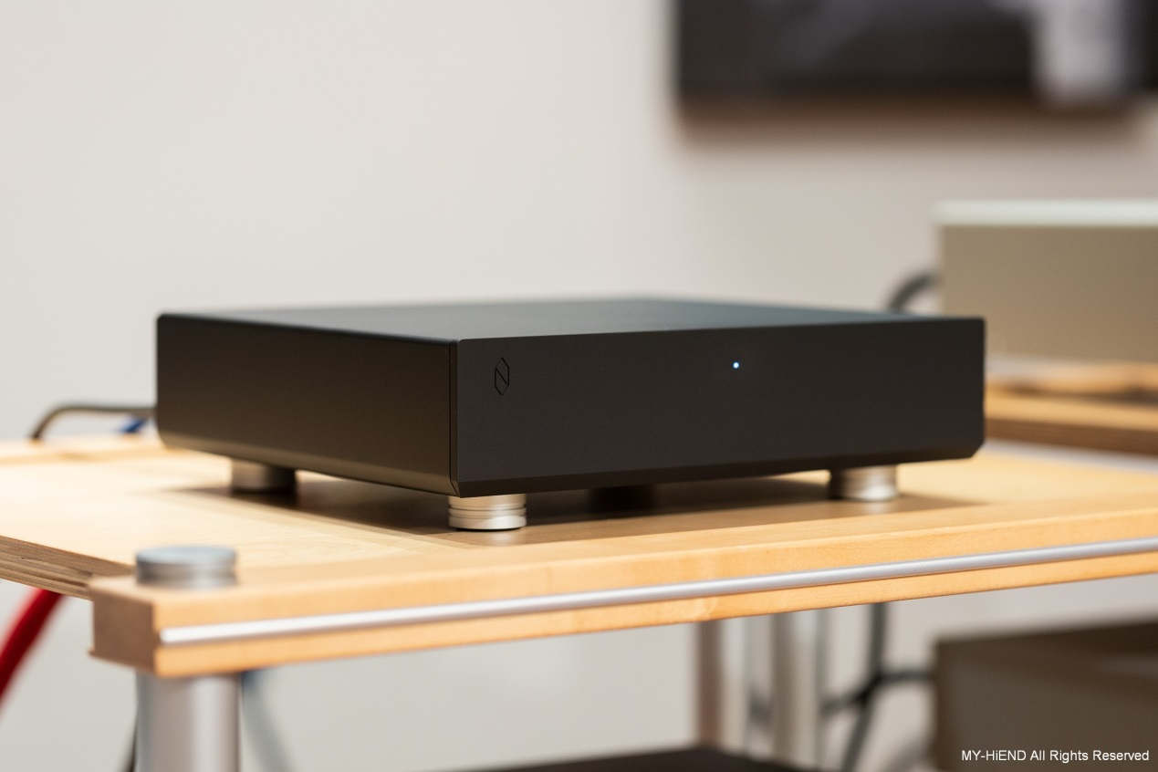
Given their implementation of network streaming functionality, it is evident that the COS Engineering team possesses a profound understanding of network communication. This expertise drove them to invest an entire year in developing the S10 network switch, leaving no stone unturned. From circuit structure design to meticulous component selection and pairing, rigorous testing, meticulous observation of experiments, iterative modifications, and ultimately finalization, every aspect was handled in-house.
The team firmly believes in the critical importance of the network switch as the final gateway for network signals entering the realm of network streaming players. It is widely recognized that this segment holds immense significance in maintaining the utmost purity of the audio source. While digital signals offer distinct advantages, the team is acutely aware of the need for meticulous attention to detail. This meticulousness is essential in mitigating potential issues such as interference, noise, and latency that may otherwise permeate the audio system via the network cable.
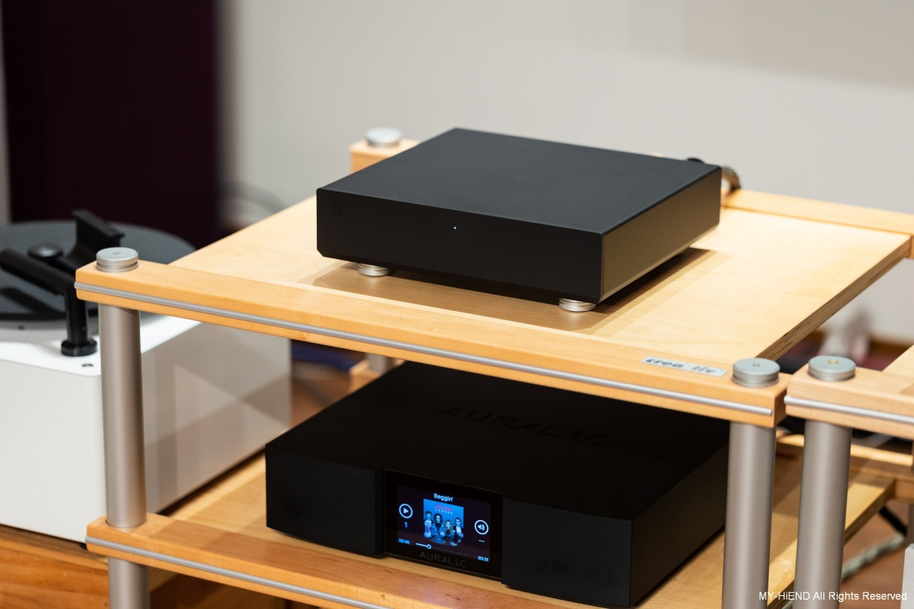
The S10 implements the same rigorous power input processing as its counterpart, the D10. The AC input module features meticulously designed filters to ensure optimal performance. The power supply further undergoes a series of procedures, including passage through an internal toroidal transformer and voltage stabilization, surpassing the standards of a typical switch. This meticulous approach demonstrates an unwavering commitment to achieving the utmost precision. The resulting positive impact on audio reproduction is unequivocal.
Furthermore, the internal circuit layout of the S10 is exclusively developed by the COS Engineering team, meticulously crafted from the ground up and refined through multiple iterations. The team has abstained from utilizing off-the-shelf circuit prototypes, affirming their exceptional technical expertise and unwavering dedication to excellence.
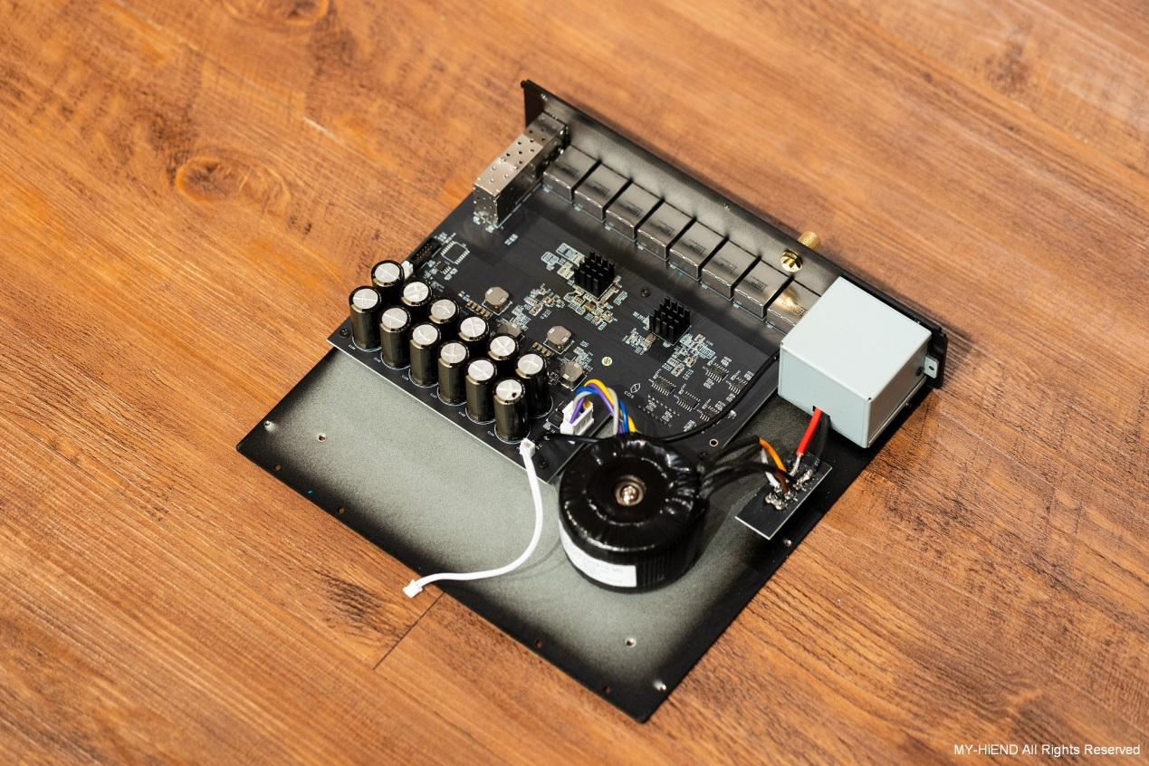
Furthermore, the internal architecture of the S10 incorporates two specialized processing chips. One chip is specifically dedicated to managing the two optical fiber transmission ports and four RJ45 transmission ports, while the other chip handles the remaining four RJ45 transmission ports. Each chip is meticulously equipped with its own high-precision crystal oscillator clock, boasting an astonishing accuracy of 0.025 picoseconds of jitter. This level of technical precision ensures optimal signal integrity and minimizes any potential timing discrepancies, resulting in superior audio performance.
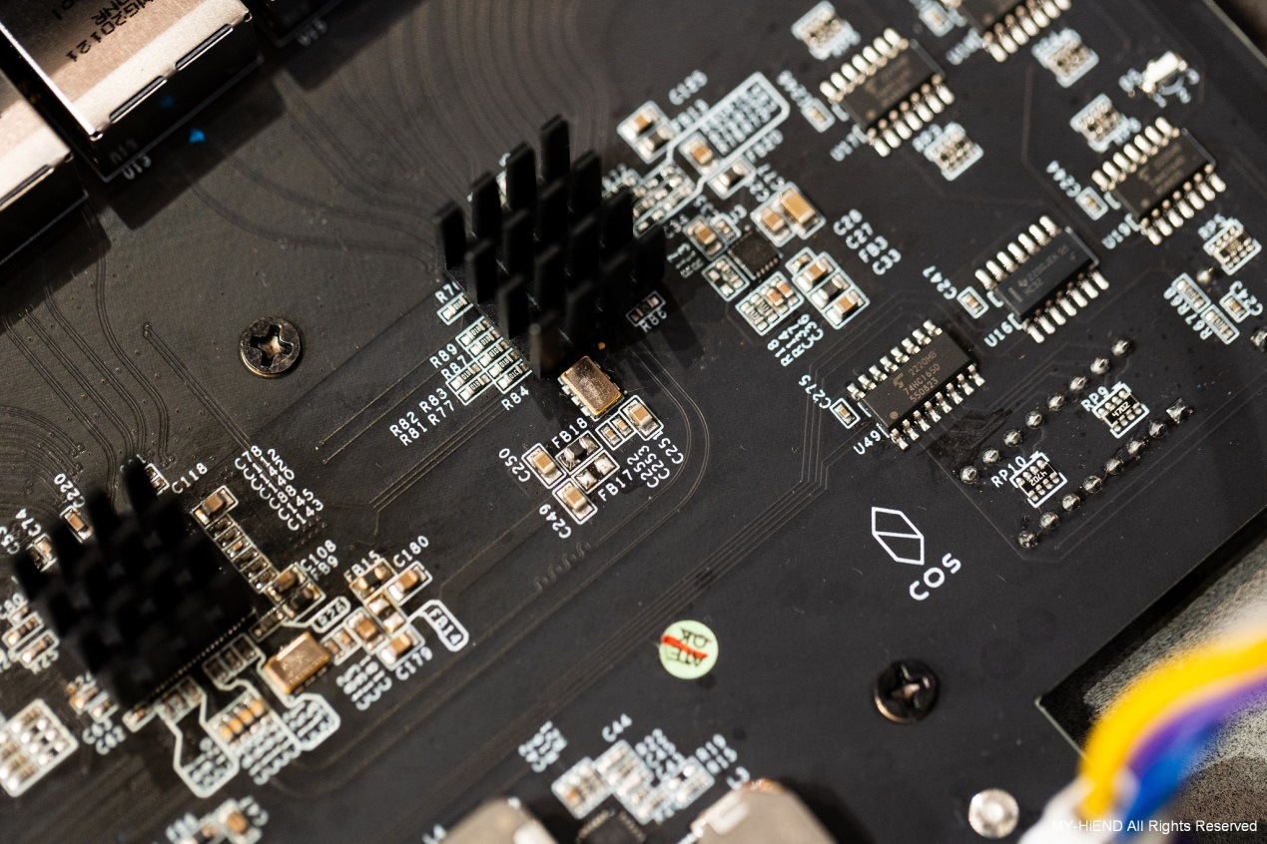
The S10 features a total of eight individual RJ45 network ports and two optical fiber ports. As explained by the COS Engineering design team, this design sets it apart from the vast majority of network switches in the market that utilize fixed modules with four RJ45 ports bound together, sharing a common ground and susceptible to mutual interference. Through their research, the team discovered that different RJ45 transmission ports can generate interference when in close proximity. To mitigate this, they deliberately chose to incorporate eight independent RJ45 ports in the S10, despite the higher manufacturing cost. This design approach significantly reduces inter-port interference and ensures enhanced performance. It is worth noting that these details might not be readily apparent to users solely based on the device's external appearance.
The design team also advises users to maximize the separation between connected devices whenever feasible. For instance, if only two ports are required, it is recommended to connect them to the far-left and far-right network ports. This strategic arrangement further minimizes the potential for interference and optimizes the overall network performance of the S10.
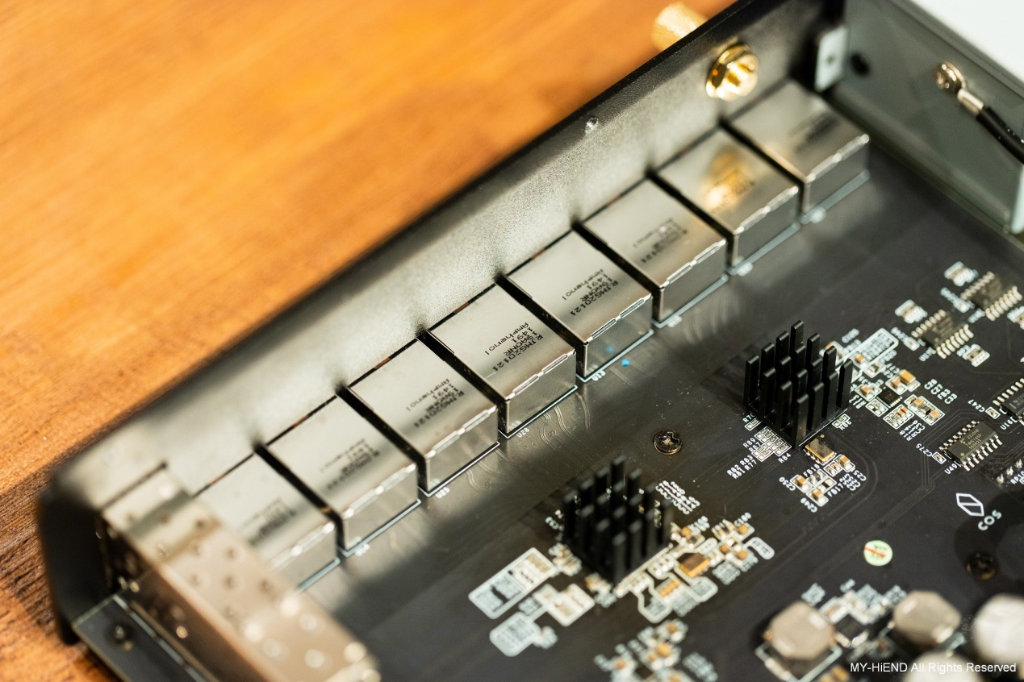
In addition to optimizing the physical layout and maximizing distance between connected devices, the S10 boasts a distinctive capability: the ability to individually disable unused network ports. This unique feature stems from the COS Engineering team's meticulous attention to detail. They recognized that standard network switches, irrespective of whether a network cable is connected, continuously communicate with the ports to detect any network activity. This constant signaling, even when there is no data transmission, can have an adverse impact on audio performance.
To address this concern, the S10 incorporates a dedicated switch on the underside of the device. Users can selectively deactivate unused network ports, thereby preventing unnecessary communication and potential interference. This innovative design distinguishes the S10 as one of the rare audiophile-grade network switches to offer this level of control and precision. Based on our extensive knowledge and recent industry experience, such a feature is exceptionally rare among network switches available in the market.
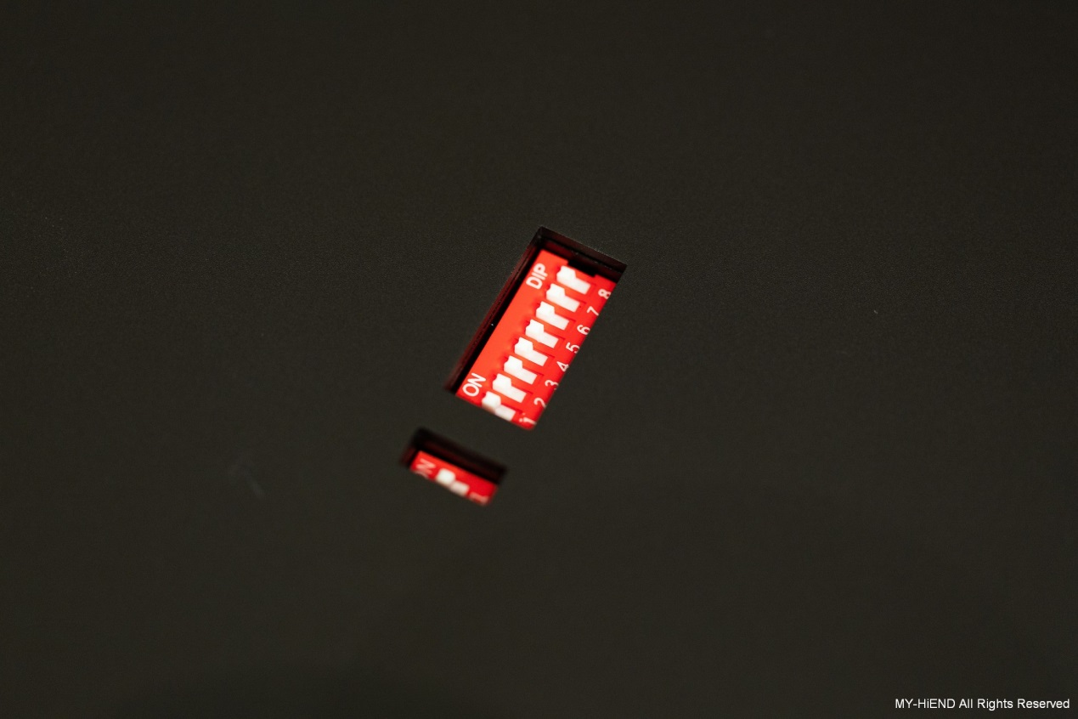
The S10 showcases meticulous attention to detail in its chassis construction. Designed to combat external radio frequency interference, the enclosure is predominantly crafted from high-quality aluminum, with the exception of the steel bottom panel. The aluminum construction provides effective shielding, ensuring minimal impact from surrounding wireless signals. The front panel is meticulously shaped using precision CNC cutting techniques, adding to the visual appeal of the device.
Extensive research by the COS Engineering team revealed the significance of chassis weight in minimizing vibrations and enhancing audio performance. To address this, the S10 incorporates a steel bottom panel, increasing the overall mass and stability of the unit. The exterior undergoes a sophisticated sandblasting process, delivering a refined texture and aesthetic that surpasses standard metal finishes. The main body of the unit is expertly constructed using aluminum and features cone-shaped spikes with vibration-damping rubber feet. It is strongly recommended to position the S10 on an audio rack or dedicated shelf, optimizing its performance by providing a stable and isolated platform for unrivaled audio reproduction.
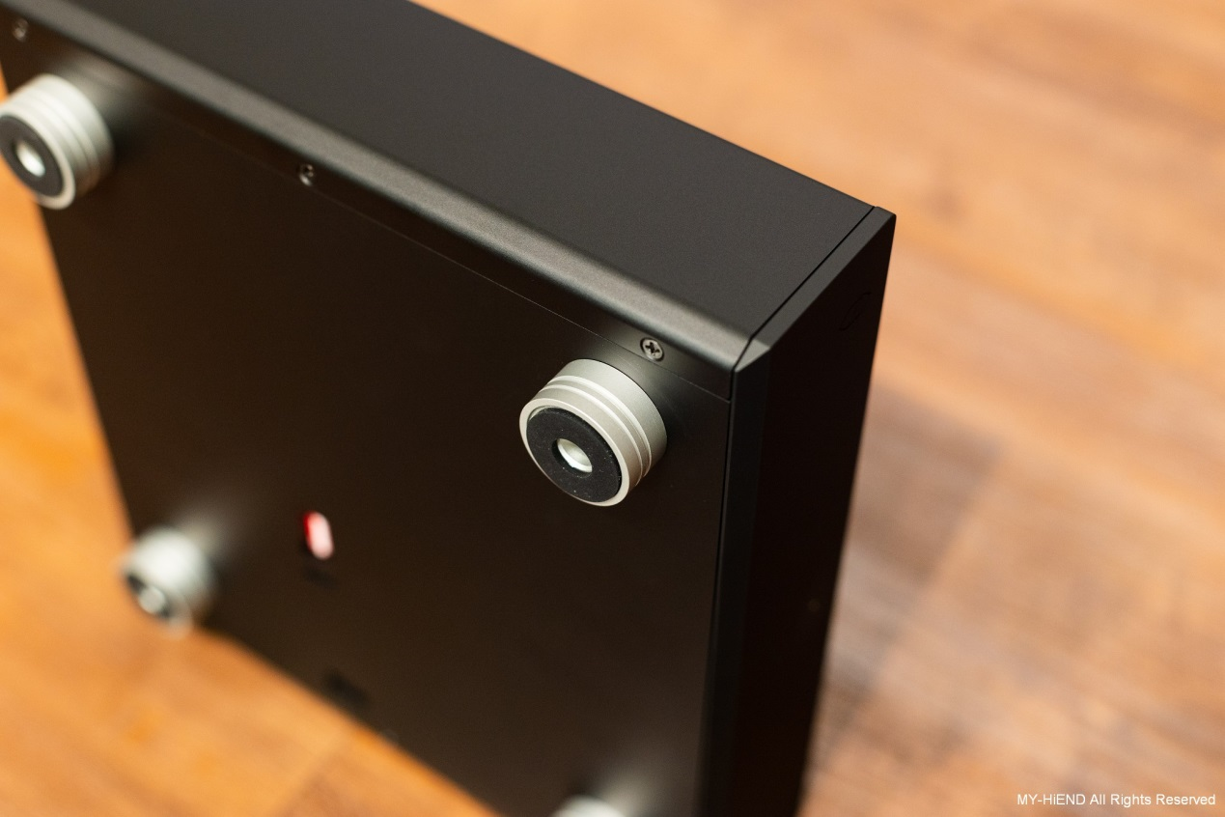
During the rigorous testing phase, we meticulously connected all the network components involved, including the NAS housing the Roon Core, the external internet sourced from the router, and the digital streaming player, to the COS S10 Switch. Our choice of amplification and speakers comprised our well-established and extensively used equipment, affording us a deep familiarity with their sonic characteristics. As a result, the transformative impact on the sound quality when we introduced the COS S10 as our network switch was readily apparent, requiring no discerning ears to perceive the significant improvements.
Drawing upon the reference album "Gloria" by Sam Smith, the initial moments of playback immediately unveiled a heightened sense of cohesion and musical integrity. The background exhibited exceptional purity, devoid of any contamination or sonic congestion. The overall sonic panorama was characterized by immaculate cleanliness and generous spatial expansion. Despite its genre as popular music, the reproduction remained utterly devoid of any hint of clutter or listener fatigue. The vocal performance exhibited striking clarity, capturing minute nuances and delivering an evocative presence. Imaging was rendered with remarkable precision, boasting a lush and seamless portrayal devoid of any tonal artifacts. Moreover, the S10 demonstrated a marked enhancement in low-frequency reproduction, showcasing superior cohesiveness, agility, and spatial articulation. Consequently, the music unfolded with a heightened sense of three-dimensionality, captivating the listener with its captivating depth and intricate layering.
The introduction of the COS S10 Switch unquestionably and unequivocally elevated the sonic performance to a level of unrivaled sophistication. Its meticulous implementation resulted in an immersive and refined listening experience, surpassing conventional expectations across the entire sonic spectrum.
In our meticulous evaluation, we commenced the assessment with the rendition of "I Will Always Love You" by John Adams. Noteworthy observations were made regarding the sonic rendition, characterized by exquisite nuance and refinement, accompanied by an intensified sense of darkness and depth in the background. The initial appearance of the piano or vocals possessed a heightened three-dimensionality, showcasing a greater precision and solidity in their sonic presence. The imaging of the piano exhibited exceptional clarity, emphasizing the augmented sense of sonic coherence, with each keystroke resonating with heightened spatiality. Similarly, the vocals exuded a commendable sense of cohesion, creating an auditory perception of the sound converging in a precise focal point. As the lyrics introduced the opening line of "I Will Always Love You," the sound commenced its diffusion from the focal point, radiating in a meticulous manner that merged intricacy and magnificence, thus engrossing the listener in an enveloping sonic panorama.
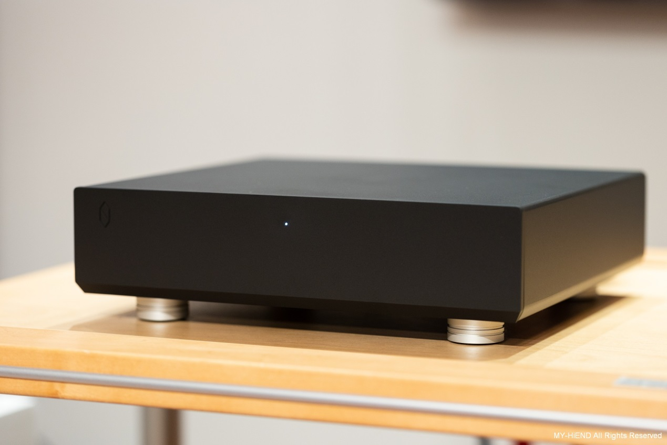
The S10 exhibits remarkable prowess in rendering diverse sonic characteristics. The lower octave of the piano resonates with a velvety warmth, delivering a poised and serene tonality that captivates the listener. Its mellowness adds a touch of depth and tranquility to the low-frequency notes, creating a sonic landscape of comfort and composure. Moving to the middle and upper registers of the piano, the S10 maintains a translucent quality, allowing each individual note to radiate with a radiant aura. The sound possesses an inherent luminosity, evoking a sense of ethereal brilliance without sacrificing body or substance. As for vocals, the S10 effortlessly navigates the intricate nuances of pitch modulation, resulting in seamless transitions between true and false tones. The voices emanate with a compelling authenticity, exhibiting a rich timbre and an expansive sense of space. Immersed in the listening experience, one cannot help but feel as if they are not merely hearing music, but rather visually perceiving the music unfolding right before their eyes.
Continuing with Samara Joy's "I Miss You So" as a reference, upon listening, I observed a heightened sense of depth in the lower frequencies, resulting in a more distinct separation between the bass and the piano. The music retained its lively character, yet it appeared noticeably clearer, offering an increased level of clarity and a heightened sense of comfort. The overall sound also exhibited a notable refinement, particularly evident in the resonance of the low-end strings, which showcased enhanced resonance and a heightened envelopment of the bass frequencies.
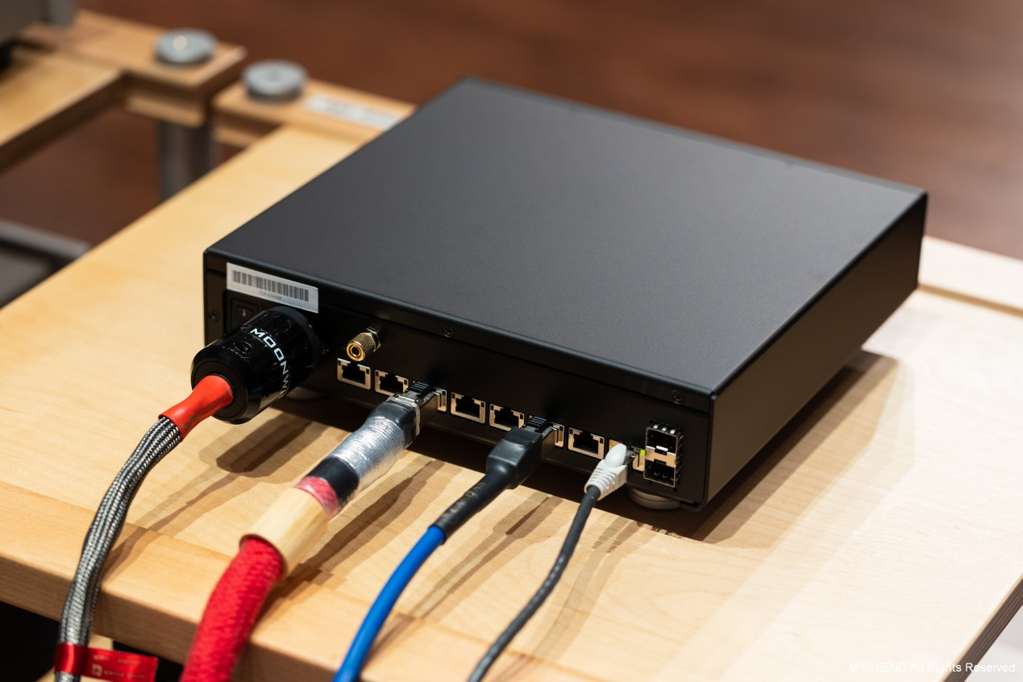
The vocals, on the other hand, exhibited a slightly retracted quality, creating a focused and concentrated auditory experience. This imparted a sense of thickness and organic texture to the vocal performance. In the introductory section of the song, the vocals were delivered with a gentle and nuanced approach, at times delicately ethereal and occasionally adorned with subtle coquettishness. As the resonance of the drums became more pronounced, the vocals assumed a more prominent role, allowing for the subtle intricacies and alluring qualities to be accentuated further. This allure captivated the listener's auditory perception, resulting in a heightened sense of astonishment and engagement.
In conclusion, when examining the song "Eyes Closed" by Ed Sheeran, released in 2023, it is noteworthy to highlight the exemplary sonic attributes observed. The commencement of the track introduces a prominent and arresting plucking sound that instantaneously captures the listener's attention. Notably, the sonic rendition exhibits exceptional clarity and distinctiveness, accompanied by a remarkable sense of elasticity. This distinct plucking sound persists throughout the composition, maintaining its discernible presence amidst the complexity and liveliness of subsequent sections.
Even as the song progresses and delves into more intricate and vibrant passages, the aforementioned plucking sound remains resolute and impervious to being overshadowed or subdued by the introduction of additional instrumental layers or the elevation of vocals. On the contrary, its vivid and well-defined nature endures, allowing it to retain its prominence within the sonic landscape.
Furthermore, as the composition unfolds and ventures into sections characterized by a greater emphasis on low-frequency content, the delicate intricacies of the guitar strings persistently maintain their clarity and audibility. The timbral quality of the strings remains vivid and animate, with their resonant characteristics impeccably preserved. Noteworthy is the meticulous attention to detail, as even during the song's denouement, the strings' decay is beautifully rendered, resulting in a captivating and dynamically rich conclusion.
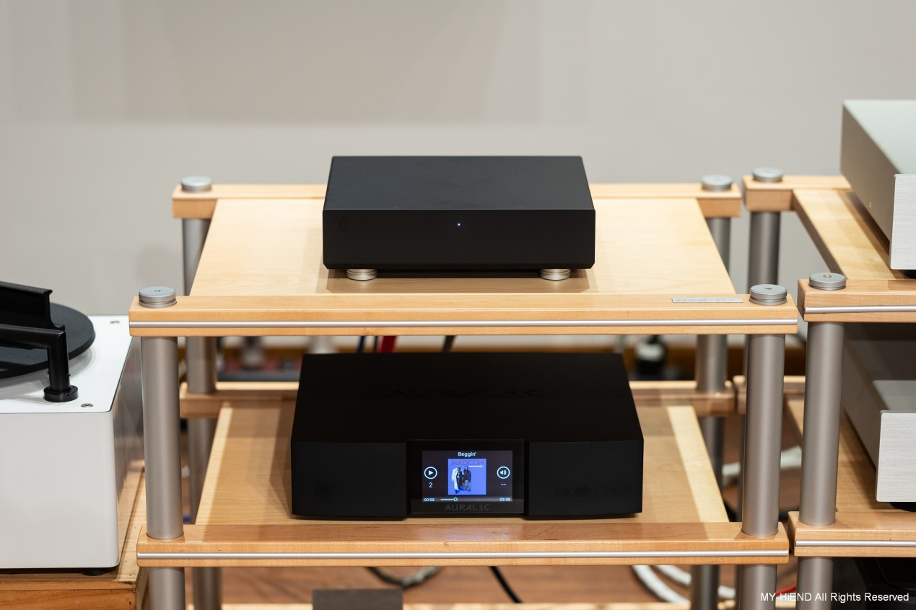
As the music progresses into its later stages, the discernible retention of sonic details becomes increasingly evident. The exceptional separation and spaciousness between the individual sound elements contribute to the distinct clarity and visibility of each sonic nuance. Previously, there might have been a perceived looseness and expansion in the low-frequency range. However, upon repeated playback sessions with the COS S10, it becomes apparent that the low-frequency impact, particularly in the drum beats, remains resolute without compromise. Moreover, the low-frequency contours are distinctly delineated, and there is a discernible clarity in the trailing edges of the sound, indicative of meticulous control and a subtle augmentation of envelopment.
While the low-frequency performance receives a notable boost, the rendering of vocals and instruments remains unequivocally precise, devoid of any perceptible ambiguity or convolution. The individual tonal characteristics of vocals and instruments are impeccably preserved, without any intrusion or distortion. This pristine separation allows the vocals to blossom with enhanced allure, accentuated by a refined sense of spatial airiness. The transitions in the sound exhibit a heightened prominence and significance.
In summary, the COS S10 showcases an exceptional ability to faithfully reproduce intricate sonic details throughout the composition. The controlled and articulate low-frequency response adds depth and dimension, while the vocals and instruments maintain their distinct identities with immaculate clarity. The overall result is an enthralling auditory experience characterized by heightened sonic fidelity, precise spatial imaging, and an enhanced sense of sonic realism.

